**LAB 7: Application of Decoder, Recap of Logisim**

**Question 1: Write a Verilog code to implement BCD to seven segment display Decoder. Prepare the Truth Table and circuits and verify the same using Test Bench.**

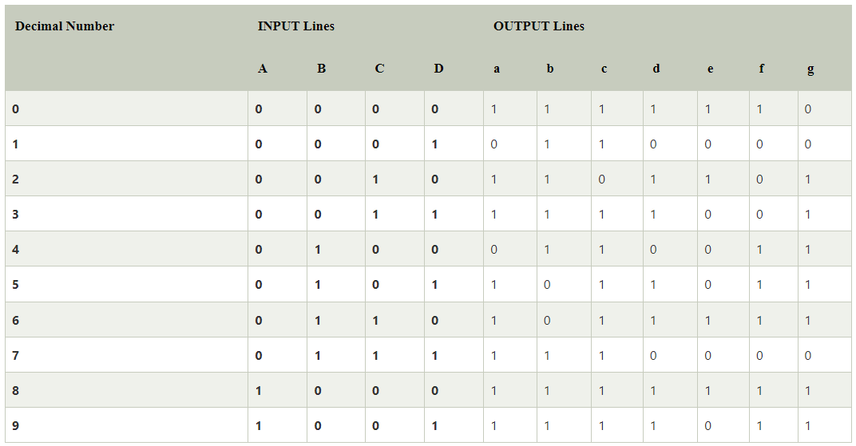 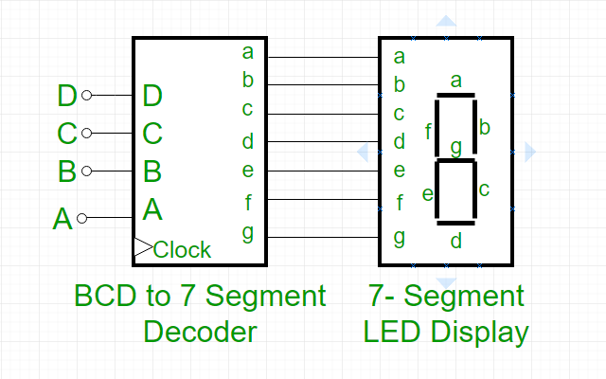

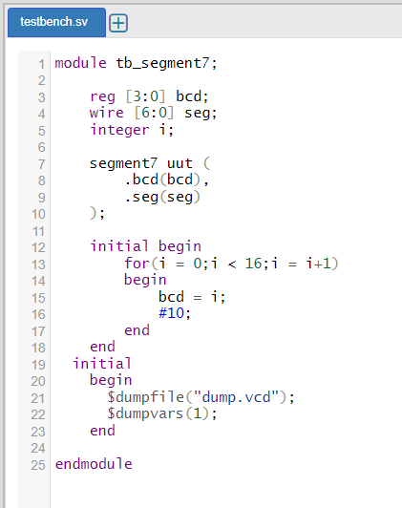 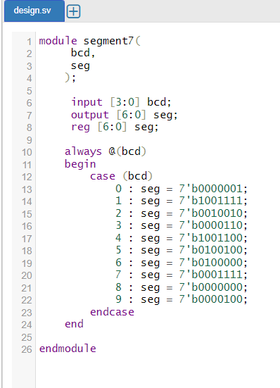



**Question 2: Design a 3:8 Decoder using Logisim.**

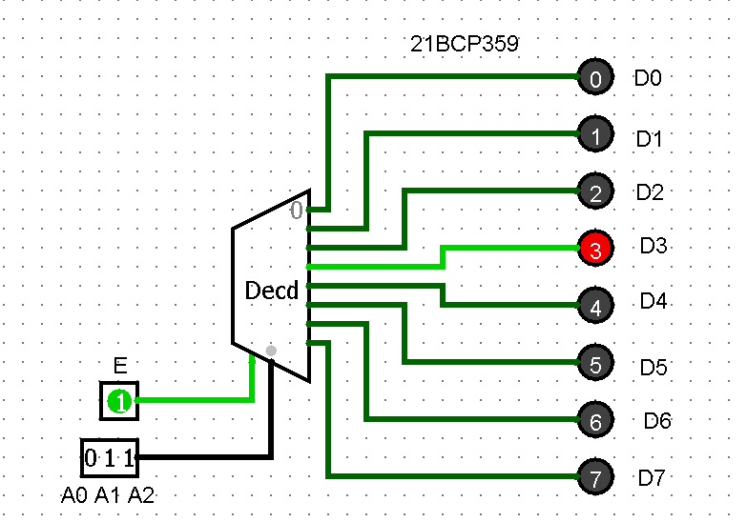

**Question 3. Design a 3:8 Decoder using two 2:4 Decoder using Logisim.**

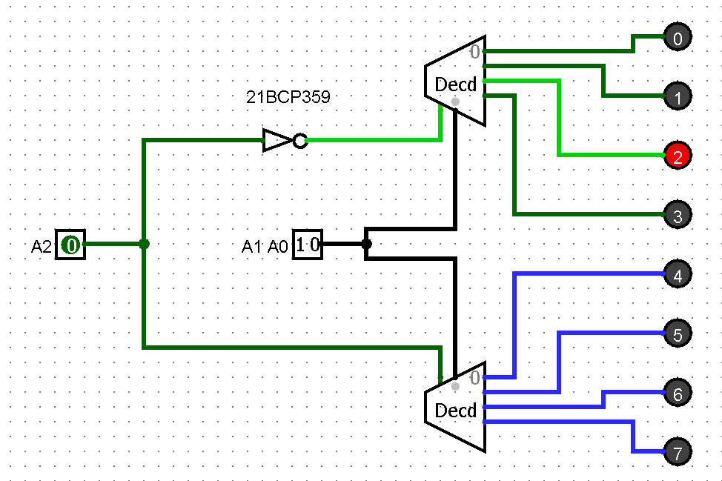

**Question 4. Design an 8:3 Priority Encoder using Logisim.**

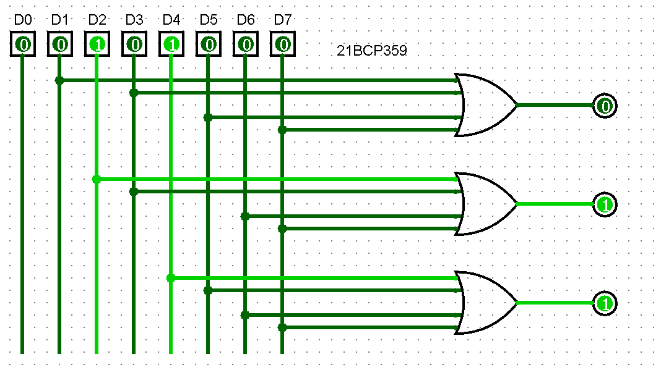

**Question 5. Design a 4:1 Multiplexer using Logisim.**

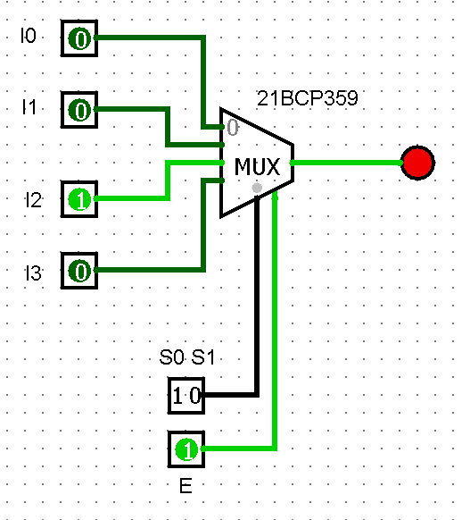

**Question 6. Design a 1:8 Demultiplexer using Logisim**

